**EXPERIMENT 4**

**AIM:**

1. **Write a JavaScript program to set the background color and highlight the text of a paragraph with bold.**

**CODE:**

<!DOCTYPE html>

<html lang="en">

<head>

<meta charset="UTF-8">

<meta name="viewport" content="width=device-width, initial-scale=1.0">

<title>Paragraph Styling</title>

</head>

<body>

<div class="container">

<h1>Paragraph Styling</h1>

<div class="form-group">

<label for="bgcolor">Background Color:</label>

<input type="color" id="bgcolor" value="#ffffff">

</div>

<button onclick="applyStyles()">Apply Styles</button>

<div class="result">

<p id="textParagraph">This is a sample paragraph. It will be styled with background color and bold text.</p>

</div>

</div>

<script>

// Function to apply background color and bold text function applyStyles() {

// Get the background color value

const bgcolor = document.getElementById('bgcolor').value; const paragraph = document.getElementById('textParagraph');

// Apply the styles paragraph.style.backgroundColor = bgcolor; paragraph.style.fontWeight = 'bold';

}

</script>

</body>

</html>

**OUTPUT:**

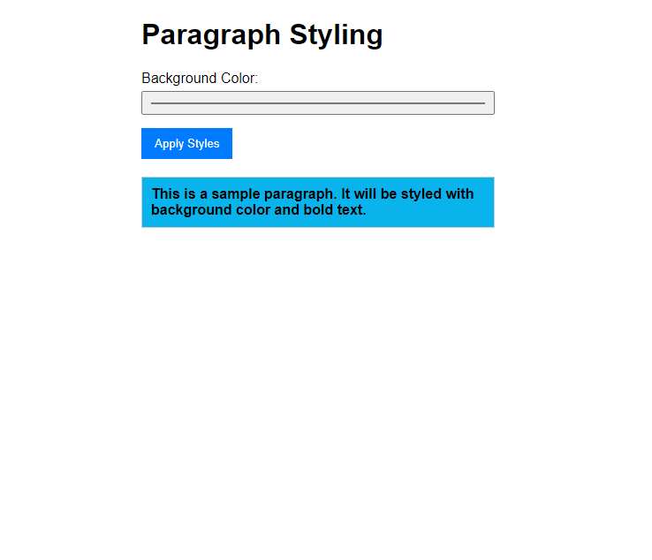

1. **Write a JavaScript program to which will have a Class Person (name, age). Person class will have a method to display the data items of it. Derive a Class Student (name, age, course, marks) from Student. Display the details of 2 students with name and age.**

**CODE:**

<!DOCTYPE html>

<html lang="en">

<head>

<meta charset="UTF-8">

<meta name="viewport" content="width=device-width, initial-scale=1.0">

<title>Student Information</title>

</head>

<body>

<div class="container">

<h1>Student Information</h1>

<div class="form-group">

<label for="name1">Student 1 Name:</label>

<input type="text" id="name1">

</div>

<div class="form-group">

<label for="age1">Student 1 Age:</label>

<input type="number" id="age1">

</div>

<div class="form-group">

<label for="course1">Student 1 Course:</label>

<input type="text" id="course1">

</div>

<div class="form-group">

<label for="marks1">Student 1 Marks:</label>

<input type="number" id="marks1">

</div>

<div class="form-group">

<label for="name2">Student 2 Name:</label>

<input type="text" id="name2">

</div>

<div class="form-group">

<label for="age2">Student 2 Age:</label>

<input type="number" id="age2">

</div>

<div class="form-group">

<label for="course2">Student 2 Course:</label>

<input type="text" id="course2">

</div>

<div class="form-group">

<label for="marks2">Student 2 Marks:</label>

<input type="number" id="marks2">

</div>

<button onclick="displayStudentInfo()">Display Student Details</button>

<div class="result">

<p id="studentDetails"></p>

</div>

</div>

<script>

// Person class definition class Person {

constructor(name, age) { this.name = name; this.age = age;

}

display() {

return `Name: ${this.name}, Age: ${this.age}`;

}

}

// Student class definition class Student extends Person {

constructor(name, age, course, marks) { super(name, age);

this.course = course; this.marks = marks;

}

display() {

return `${super.display()}, Course: ${this.course}, Marks: ${this.marks}`;

}

}

// Function to handle input and display student info function displayStudentInfo() {

// Get user input values for Student 1

const name1 = document.getElementById('name1').value;

const age1 = parseFloat(document.getElementById('age1').value); const course1 = document.getElementById('course1').value;

const marks1 = parseFloat(document.getElementById('marks1').value);

// Get user input values for Student 2

const name2 = document.getElementById('name2').value;

const age2 = parseFloat(document.getElementById('age2').value); const course2 = document.getElementById('course2').value;

const marks2 = parseFloat(document.getElementById('marks2').value);

// Validate input for both students

if (isNaN(age1) || isNaN(marks1) || isNaN(age2) || isNaN(marks2) || age1 <= 0 || marks1 < 0 || age2 <= 0 || marks2 < 0) {

document.getElementById('studentDetails').innerText = "Invalid input. Please enter valid numbers for age and marks.";

return;

}

// Create Student instances

const student1 = new Student(name1, age1, course1, marks1); const student2 = new Student(name2, age2, course2, marks2);

// Display student details

const studentDetails = `${student1.display()}<br>${student2.display()}`;

document.getElementById('studentDetails').innerHTML = studentDetails;

}

</script>

</body>

</html>

**OUTPUT:**

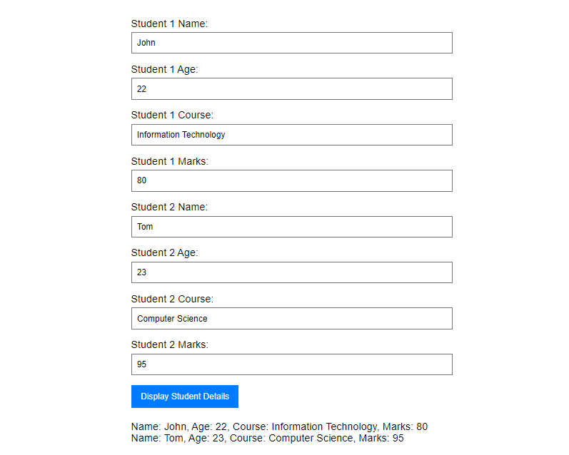

**CONCLUSION: Hence, we have successfully implemented JavaScript program to style a paragraph with it’s background and derive class.**